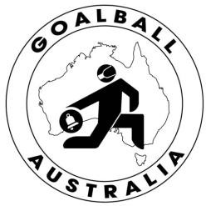
THE “ORIGINAL” BLIND PARALYMPIC TEAM SPORT
GOALBALL AUSTRALIA

ABN 75011723437

Secretary: Olivia Muller
0430248446
australiangoalball@gmail.com

NOTICE OF MOTIONS

for

GOALBALL AUSTRALIA

ANNUAL GENERAL MEETING

NOTICE IS HEREBY GIVEN that the 2020 ANNUAL GENERAL MEETING of Goalball Australia will be held via Zoom, teleconference.

Wednesday 30th December 2020 commencing at 7pm AEDST

Any Notice of Motions must be received at Goalball Australia by 5pm on 2nd December 2020.

Nominations for the Board must also be received by 5pm on 2nd December 2020.

By order of the Board
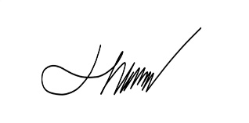
Olivia Muller
Secretary
Goalball Australia

M +61 430248446
australiangoalball@gmail.com
PO Box 48 Woodcroft SA 5162

